Project Design Phase-II
Data Flow Diagram & User Stories

Date | 12 July 2026
Team ID
Project Name | Book Store
Maximum Marks | 4 Marks

Data Flow Diagrams:
A Data Flow Diagram (DFD) is a traditional visual representation of the information flows within a system. A neat and clear DFD can depict the right amount of the system requirement graphically. It shows how data enters and leaves the system, what changes the information, and where data is stored.
Example: DFD Level 0 (Industry Standard)
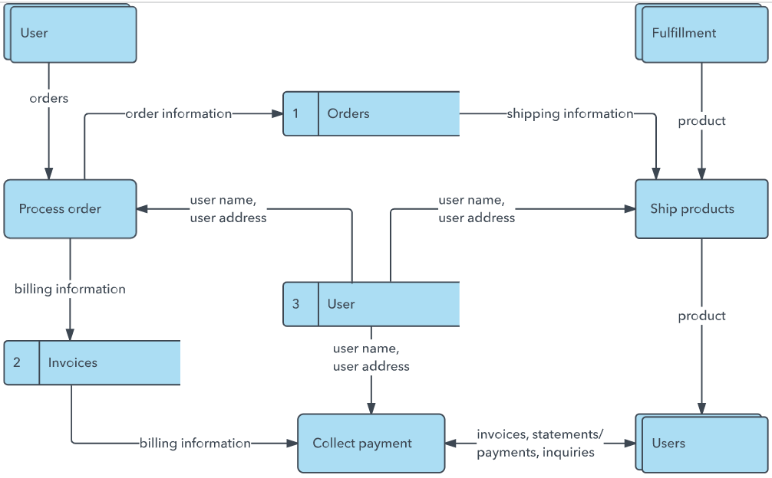
Example: (Simplified)


User Stories
Use the below template to list all the user stories for the product.
User Type | Functional Requirement (Epic) | User Story Number | User Story / Task | Acceptance criteria | Priority | Release
User | Registration | USN-1 | As a user, I can register for the application by entering my email, password, and confirming my password. | I can access my account / dashboard | High | Sprint-1
 | Login | USN-2 | As a user, I can login. | User logs in successfully | High | Sprint-1
 | Browse Books | USN-3 | As a user, I can view books. | Books are displayed | High | Sprint-2
 | Search Books | USN-4 | As a user, I can search books. | Matching books are displayed | Medium | Sprint-2
 | Cart | USN-5 | As a user, I can add books to the cart. | Book is added to the cart. | High | Sprint-3
 | Orders | US-6 | As a user, I can place an order | Order is created successfully. | High | Sprint 3
Seller | Manage Books | US-7 | As a seller, I can add and manage books. | Books are updated successfully | Medium | Sprint 4
Admin | Dashboard | US-8 | As a admin, I can monitor users, books, orders | Dashboard displays correct data.

